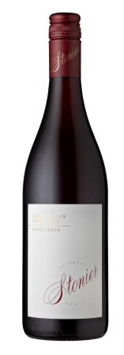 Stonier Pinot Noir 2018

Hand-picked Pinot Noir grapes were de-stemmed into small open two and three tonne fermenters, with daily hand plunging and gentle pump overs during fermentation. Almost 3% of the fruit was fermented seperately as whole bunches. After 12-22 days on skins, the wine was pressed to a mix of fine grain French oak puncheons and barriques (10% new) for malo-lactic fermentation and maturation (10 months). A portion of the final blend was also retained in stainless steel tanks (30%), to promote the vibrant fruit profile we cherish with Stonier Pinot Noir.
An abundance of red fruits of the forest to start with, with sweet and bright juicy flavours. Beneath this though there is an alluring brooding fruit profile more savoury in nature that will become more prominent with time, framed nicely by some formidable tannins so typical of the vintage.
Alcohol 13,8 %

