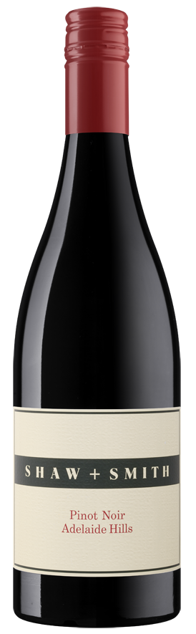 2018 Shaw + Smith Pinot Noir

Notes
Perfumed and delicate with silky tannins. Enjoy in a large red wine glass, with some charcuterie. Ideal drinking until 2021. Ideal serving temperature: 16-18°C. Produced using sustainable practices. Suitable for vegans. The 2018 vintage has a concentrated core of red berry fruits including raspberries and cherries. It is vibrant and more opulent than other years.

Outstanding quality from a growing season that threatened, at times, to be tricky. After some heat in January, the moderate, dry and sunny months of February and March delivered beautifully balanced fruit. Crop levels were slightly below average, enhancing flavour and intensity. Pinot Noir is the most temperamental of varieties and remains a challenge for site, season and winemaking - Shaw + Smith has joined the quest albeit in a ‘small batch’ way. First produced experimentally in 2004 and commercially in 2007. Site selection, the right clonal mix, minuscule yields and fastidious vineyard management are essential to success.

