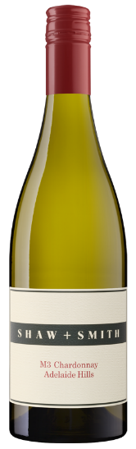 Shaw & smith M3 Chardonnay 2018
Try with pan fried whiting, Ideal drinking until 2028, Ideal serving temperature: 10 - 12°C, Produced using sustainable practices, Suitable for vegans

Tasting Notes: Aiming for elegance, restraint and the ability to age, acid is bright and there’s generosity of flavour. Typically it shows white flowers, citrus, and nectarine notes

Growing and Making: Outstanding quality from a growing season that threatened, at times, to be tricky. After some heat in January, the moderate, dry and sunny months of February and March delivered beautifully balanced fruit. Crop levels were slightly below average, enhancing flavour and intensity.

Story: The Shaw + Smith winery was built in 2000 giving us the ability to whole-bunch press chilled grapes for the first time, and underpinning the evolution of style from that first M3 Chardonnay vintage in 2000 through to the present day. The most significant event since then came in 2012 with the purchase of the Lenswood Vineyard. Chardonnay was originally planted in Lenswood for sparkling wine production but it now fulfils its potential for fine still wine, with finesse, flavour, and great natural acidity.

Reviews, GOLD - 2019 Royal Melbourne Wine Show, Trophy - Winner of the Francois de Castella Trophy for Best Young White Wine, Trophy - Consistency of Excellence Medal, GOLD - James Halliday Chardonnay Challenge
Campbell Mattinson - The Wine Front - November 2019 Shaw + Smith M3 Chardonnay is a wine of note. It’s a wine with a view, as in we all have one of it. It’s come a long way over the years. I like my flint and funk but when I first opened this it was alarming. It was a matchbox factory. Some chardonnays need a decant and a wait. Give this time and it shows both power and poise, its grapefruit, custard apple and stone fruit flavours woven expertly with cedar, oatmeal, almond milk and matches. It has a quartz-like aspect, a bristle to its brilliance. It’s narrow but it’s not lean; there’s more than enough power to its fruit. It should drink quite sensationally, from appropriate glassware, in another 2-4 years. 96 Points.

