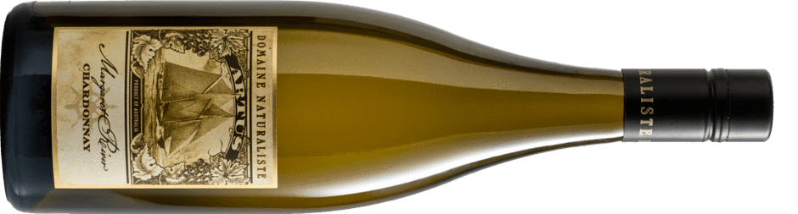

2018 Artus Chardonnay
Artus is an artistic translation of our local Gin Gin clone into wine. It is a provocative, complex and textural wine exuding the seductive spirit of “old world” chardonnay. The vines have been managed to allow only dappled light into the fruiting zone. This promotes flavor development, low tannins and bright levels of natural acidity. The fruit is farmed in the cool southern end of Margaret River. The tiny 100g Gin Gin clusters are hand harvested at first light to preserve freshness of fruit.
Flavours of fresh nectarines and candied pecan nuts are supported by aromas of poached pears and marzipan.

ALCOHOL: 13.0% by Vol | 7.7 Standard Drinks

FOOD MATCHING: Roast free-range chicken | salmon | smoked butter on sourdough

GROWING SEASON: A long and gentle vintage weather pattern, slightly cooler than the long-term average. The fruit gained lovely perfumes and textures while maintaining a magnificent verve.

VARIETY: Gin Gin clone Chardonnay | Single Vineyard

WINEMAKING: Cloudy juice | handpicked fruit whole-cluster pressed | wild yeasts full malo‐lactic fermentation | sur lie
Artus creates its own story.

MATURATION: 40% new 228 L medium toast French oak. Barriques Vosges and Allier for 10 months.

CELLARING POTENTIAL: Attractive in youth | up to 8 years maturation.

HARVESTED: 27th February 2018

