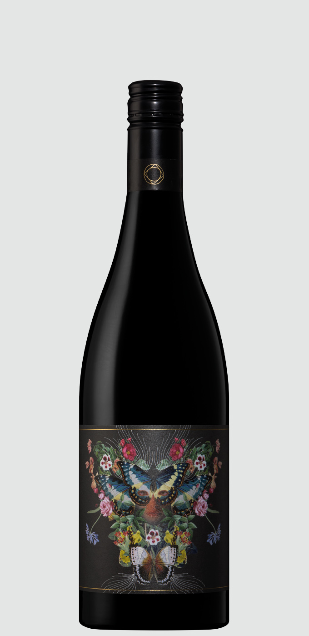 Adelina 2018 Shiraz Mataro

Variety: 68% Shiraz / 32% Mataro
Vintage: 2018
Region: Clare / Springfarm
Vineyard: Adelina / McDowell-Brown
Basic Viti Info: Predominantly from vines planted between 1904 and 1920’s. Typically red sandy sites on clay base, slate and limestone predominate as well. Elevation varies between 430-460m. All within a close proximity of the Adelina Estate vineyard.
Winemaking: fruit was hand-picked, destemmed and fermented with selected yeast. Maceration times varied between 35 and 45 days on skins. Post pressing the wine was racked to large format French oak (35%) and concrete tank (65%) for malo (indigenous bacteria) and maturation. 6,306 bottles produced.

