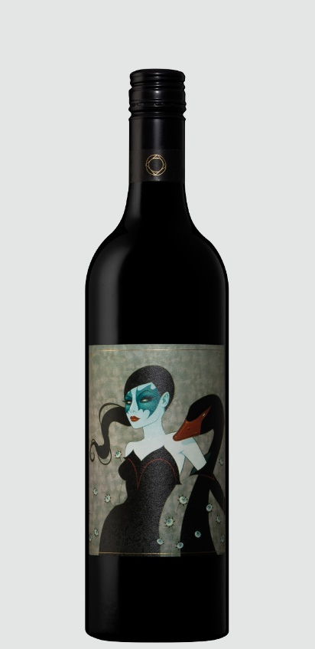 Adelina Estate Shiraz 2018
Variety: Shiraz
Vintage: 2018
Region: Clare / Springfarm
Vineyard: Adelina Block 4

Basic Viti Info: Vines of about 100 years old, beset red sand, mild clay, slate and limestone on a clay base.
Winemaking: Hand picked, destemmed and about 50% whole berry fermentation. 27 days on skins, pressed to larger format neutral French oak for 8 months. 1518 bottles made.

