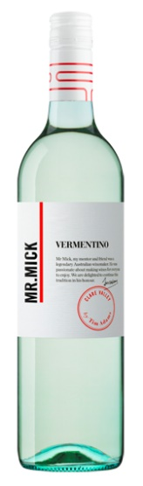 Tim Adams Mr. Mick Vermentino 2017
Country: Australia
Region: Clare Valley
Alcohol: 12%
Bottle size: 750 mL

Description
This wine has grapefruit, apple and nashi pear aromas and flavours, modelled in the classic Italian style with just a touch of fruit sweetness to balance the refreshing minerality and spritely natural acidity.
Winemaking Notes
The warm growing conditions in the Clare Valley are ideal for Vermentino, which has its origins in Italy.
Grapes were harvested at their peak flavour maturity from a single vineyard within the southern Clare Valley.
After a short skin contact time, the juice was separated from skins, cold settled and fermented for 14 days. Careful attention to fining ensures a rich and textural yet seamless palate.
Food Pairing
It is a great wine just to sit, sip and enjoy for its individuality, or try with a varied range of food, particularly good with seafood!

