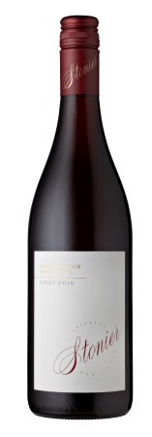 2017 Stonier Pinot Noir
The hand-picked Pinot Noir grapes were de-stemmed into small open two and three tonne fermenters, with daily hand plunging and gentle pump overs during fermentation. Approximately 3% of the fruit was fermented in separate two tonne fermenters as whole bunches. After 12-22 days on skins, the wine was pressed to a mix of fine grain French oak puncheons and barriques (10% new) for malo-lactic fermentation and maturation (10 months). A portion of the final blend was also retained in stainless steel tanks (20%), to promote the vibrant fruit profile we cherish with Stonier Pinot Noir.
Nice classic Pinot palate, with savoury and tight tannins at this youthful stage offering a firm direction. Lots of cherry and spice flavours, opening up to reveal a nice juiciness and increasing flavour intensity, but all within a very refined framework.
Vintage: 2017
Varietal: Pinot Noir
Alcohol %: 13.5

