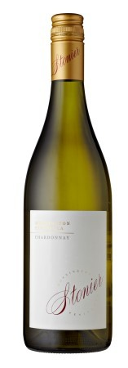2017 Stonier Chardonnay

The 2017 Stonier Chardonnay was fermented in a mix of French oak barriques and puncheons (15% new), for a total maturation period of 10 months. Several batches from our coolest vineyards were allowed to undergo the acid-softening malo-lactic fermentation (approximately 50%), with the remaining portion withheld to preserve the lovely pure flavours of a very strong Chardonnay vintage.
A very tightly wound palate, laden with a dense array of savoury citrus fruits, which gradually reveal themselves with time in the glass. There is some subtle creamy texture that will build over the first 12 months and beyond tying in nicely with a powerful structural core that drives the palate to a long finish. This is certainly a great vintage that will become more expansive and complex over the next 3-5 years.
Vintage: 2017
Varietal: Chardonnay
Alcohol %: 13.5

