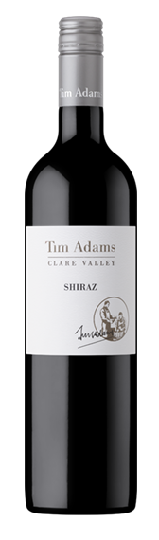 Tim Adams Shiraz 2016
Country: Australia
Region:Clare Valley
Alcohol:14.8%

Description: Our Clare Valley Shiraz selected from premium vineyard sites has produced a wine with strong regional and varietal definition. This sophisticated wine has a rich deep crimson hue with aromas and flavours of blackberry, mulberry and dark cherry. Further complexity is built through 24 months of American oak maturation. The front and mid-palate is full and soft, with flavours of small berry fruit and spice complemented by the oak. The wine finishes with integrated toasted oak and firm, structural tannin.
This elegant Clare Shiraz has power and finesse which makes it both approachable now and worthy of keeping for up to 10 years. The wine has been made naturally and may form a harmless crystalline deposit, so will benefit from decanting prior to serving.

Winemaking Notes: All components of this blend were separately fermented on skins to dryness before pressing, with only selected softer pressings returned to the wine.
The wine spent 24 months in a combination of two and three year old American oak barrels and a further 9 months in stainless tanks before blending, fining, filtering and bottling.

Food Pairing: Shiraz makes an excellent accompaniment to grilled steak and other red meat dishes.

