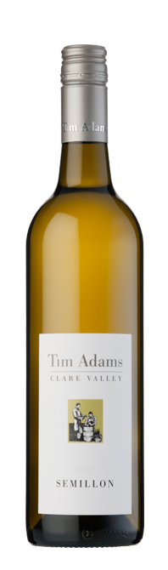 **Tim Adams Semillon 2016**

Alcohol

12.5%

Description

This aromatic wine has great balance and generous flavour typical of this variety grown in the Clare Valley.  
Fermentation in new French oak has added complexity to the grassy and plush stone fruit characters of the Semillon.  
The palate is textural and rich thanks to extended lees contact, without residual sweetness and has a long lingering finish.  
It has diverse food compatibility—in particular with seafood and pasta and may be cellared for a decade with confidence.

Winemaking Notes

Following crushing, the juice was left in contact with its skins for 12 hours to maximise fruit flavour extraction. All pressings juice was retained and has been utilised in this blend to enhance wine texture. Fermentation was conducted in new French oak barrels (80%) and stainless steel tanks (20%).  
The oak portion then remained in barrel for nine months on light lees before back blending with the balance, fining and filtration.

Food Pairing

It has diverse food compatibility—in particular with seafood and pasta