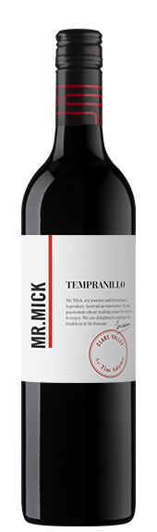 Tim Adams Mr. Mick Tempranillo 2016
Varieties: Tempranillo, Region: Clare Valley, Alcohol: 13.5%

Description
Mr Mick would have been extremely proud of this wine. Mirroring the central areas of Spain, which Tempranillo calls home, the warm dry growing conditions of the Clare Valley is the ideal climate to make this variety shine. Take it from us when we say this wine will go well with just about any food. Mr Mick enjoyed making wines for everyone to enjoy and this is yet another one that fits perfectly in the range.
Crafted in typical Mr Mick style, this wine has distinctive varietal character of cherries and strawberries, subtle French oak perfume flavours with smooth tannins, a hint of spice and a long lingering finish.
Winemaking Notes
Premium Tempranillo fruit, fermented for a week with its skins, was then gently pressed, with the pressings separated in order to ensure a smooth silky palate. The wine was then matured using French oak before fining, filtering and bottling. It is suitable for drinking anytime from the present to ten years of age.
Campbell Mattinson
Mr Mick Tempranillo 2015 - Professional September 10, 2017 14:30
And we’ve found ourselves a bargain. Clare Valley Tempranillo with all guns blazing, at a snip of a price. A snip I tell you.
It’s just an excellent wine to drink. Tou can see this being widely enjoyed. The flavour profile has a sweetness to it but it works. It tastes of redcurrant, cola, vanilla and wood spice, or thereabouts, but it’s fruit-driven and generous and just generally eager-to-please. There’s only enough tannin to give the tannin shape, which is apt in context. Love the fruit flesh here
91/100 points

