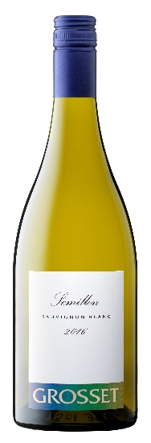 Semillon Sauvignon Blanc 2016
The 2016 continues the run of outstanding vintages for the wine and maintains its distinctive style. This year, it is quite different from 2015’s 75:25 blend with 50% Clare Valley semillon and 50% Adelaide Hills sauvignon blanc. The wine’s finesse and style remain although the higher percentage of sauvignon blanc gives it more primal fruit characters.
Grosset Semillon Sauvignon Blanc 2016 has attractive white floral and fresh herb aromatics and a tight core of pure nectarine and white peach flavours which give a pleasing mid-palate tang. The finish is zesty, powerful and of considerable length; an impressive release. The volume is down with just 500 cases released in 2016.
Ageing potential: Enjoy now or up to 15 years
Source: Semillon; Grosset Watervale Vineyard. Sauvignon blanc; Woodside, Adelaide Hills
Fining: Nil- suitable for vegans and vegetarians. Release Date: 1 September 2016
“By seeking the best expression of each variety (therefore two regions), we think that this release is one of our most convincing examples of this blend.”

Award: Tyson Stelzer’s Australian and New Zealand Wines of the Year 2017: Top 20 Wines of the Year Under $40

Reviews: Tyson Stelzer’s Australian and New Zealand Wines of the Year 2017: A different take on a previously Semillon-dominant blend, this year equal proportions of Clare Valley Semillon and Adelaide Hills Sauvignon Blanc. This is a release of character and complexity, toning the guava and lantana generosity of sauvignon blanc with the structure and drive of Semillon. The result encapsulates exuberance, structure and engaging appeal, defined by exceptional line and length. 94 Points.
Halliday Wine Companion, April/May 2017: A tried-and-true blend of Clare Valley Semillon and Adelaide Hills Sauvignon Blanc. The initial impact is the minerally lemongrass flavours and acidity of the Semillon before the back-palate, finish and aftertaste are driven by gently tropical/gooseberry fruits. 95 Points.

