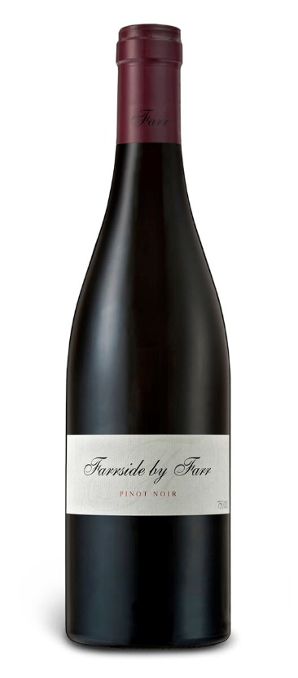2016 FARRSIDE BY FARR PINOT NOIR

Vineyard
The Farrside vineyard sits on a northeast-facing slope and consists of limestone topped with black volcanic soil. The vines were planted in 2001 and run east-west to protect the fruit from overexposure to the sun. The clones are a mixture of 114, 115, 777, 667 and MV6. Even though the Farrside and Sangreal vineyards are only 300 metres apart, the darker soils and cooler growing conditions of the Farrside vineyard mean these grapes are picked 10 to 12 days after all others and produce a more masculine and edgy wine.

Vinification
The fruit is hand-picked and sorted in the vineyard, then fermented in an open-top fermenter. Between 40 to 50 per cent of the fruit will be stemmed and then cold soaked for four days. We use only the natural yeast for the fermentation process, which takes roughly 12 days. Grape-stomping (known as pigeage) will occur two to three times a day depending on the amount of extraction required, and the wine is then placed in 50 to 60 per cent new Allier barrels by gravity. It is racked by gas after secondary fermentation, then again at 18 months to be bottled.

Tasting Note
Each vintage of Farrside pinot noir exhibits more masculinity, structure and savoury components, while deep meaty, spicy and mineral flavours also continue to evolve. A balanced array of red and black fruits, Farrside pinot noir is fresh and edgy with bucketloads of character. This is a firm yet delicate wine with a long-textured finish.

