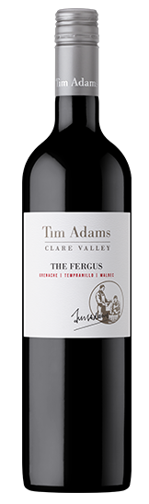 2015 Tim Adams The Fergus
Varieties: Grenache, Tempranillo, Malbec
Country: Australia Region: Clare Valley
Alcohol: 14.5%

Description : Our twenty second release of The Fergus is named after our neighbour who was good enough to sell us his Grenache grapes in the vintage of 1993, during a desperate shortage of Shiraz and Cabernet. We quickly realised that a wine born from logistics had real potential as a medium, but soft style with immediate food compatibility. This wine has lifted red berry aromas and flavours of Tempranillo, spiciness from Grenache and mid palate richness with berry and violet characters coming from Malbec. It is a luscious mouth filling wine that with careful cellaring may be kept for up to 10 years.

Winemaking Notes: Grenache grapes, left in the vineyard to fully mature, were crushed on to fermented and drained skins of Tempranillo. Fermentation lasted one week. The tanks were then topped and closed for another week for extended maceration prior to pressing off skins. A measured amount of Tempranillo and Malbec were added for added complexity and fruit expression. The wines were then racked, filtered and transferred to a mixture of older American and French oak hogsheads. The wine remained in oak for 24 months before blending, filtration and bottling. It has been sealed under screwcap for freshness and authenticity.
Food Pairing: This wine will pair nicely with duck, turkey, lamb, spicy dishes and charcuterie.

Reviews: John Rozentals PS News Professional May 5, 2019: This wine has developed into an integral cog in the Adams stable. The blend has changed over the years but its honesty of flavour has earned it a valued place in my list of favourites.
Kate Spain Adelaide Advertiser Professional May 14, 2019: With powers combined, grenache, tempranillo and malbec do good things. This is the 22nd release of The Fergus, named after a neighbour. This wine is as perky as a meerkat on high alert. Cherry and spice aromas are inviting and in the glass it’s beautifully balanced, with delicate tannins and a smoked meat finish. Delish and dangerously easy drinking. 4/5 Stars

