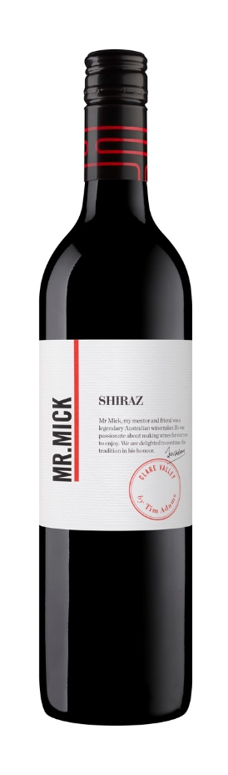 Tim Adams Mr. Mick Shiraz 2015
Varieties: Shiraz
Country: Australia Region: Clare Valley
Alcohol: 14.5%

Description: For many years Clare Valley Shiraz has captivated wine enthusiasts with its power and elegant synergism. This wine emulates just that style, graceful yet flavoursome, gentle enough to enjoy on its own or great with a diverse range of food.
Lifted violet and raspberry fruit bouquet leads the nose with nuances of vanilla oak flavour due to American oak maturation. the palate is rounded and medium bodied with silky tannins and dark cherry and ripe berries with a hint of herb and spice..

Winemaking Notes: Clare Valley Shiraz, fermented for a week with its skins using a gentle pump-over regime, was then gently pressed, with the softer pressings returned to this blend. Heavy pressings were kept separate to minimise hard, drying tannins. The wine was then matured using predominately American oak for 24 months before fining, filtration, further tank maturation and bottling. It is suitable for drinking anytime from the present to ten years of age, and will complement all red meat cuisine.

Food Pairing: A perfect match for a hearty meat dish!

