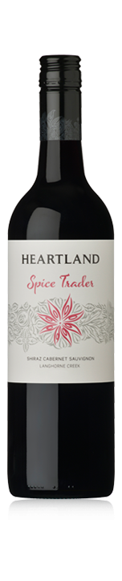 Heartland Spice Trader Shiraz Cabernet 2015
Variety: Shiraz [52%] and Cabernet Sauvignon [48%]
Region: Langhorne Creek
Soil: Sandy loam
Tasting Notes: Soft, smooth and delicious, this is an accurate and genuine expression of what Langhorne Creek has to offer. Dark fruits such as blueberries and blackberries are decorated by spice, fresh oregano and dill.
Vinification: The Shiraz and Cabernet Sauvignon are fermented separately with specific parcels included for their ability to offer greater complexity and character. Time in barrel permits a softening of the wine’s structure. It also offers a complex expression of the fruit and helps the exotic notes of spice to be discovered.
2015 Vintage: Good winter rainfall provided cover crops for a moisture-retaining mulch throughout the dry spring and summer. The lack of rainfall over the growing period led to lower yields. Summer saw mostly cool temperatures and an early vintage with most of the region’s fruit off by early April. The Langhorne Creek wine region benefits from cooling afternoon breezes from Lake Alexandrina and this season was no exception. The welcome breezes helped keep overnight temperatures down, enabling fruit to maintain natural acidity.
Alc/Vol: 14.5% Maturation Vessel: French and American oak hogsheads in combination Age of vines: 25+ years Age of barrels: 1-3 years
Time in barrel: 12 months Optimum drinking: 1-5 years
Suitable for vegans: Yes

